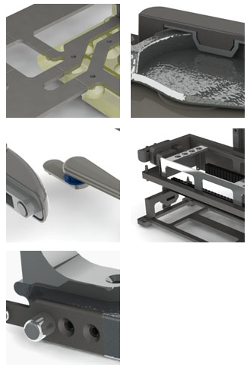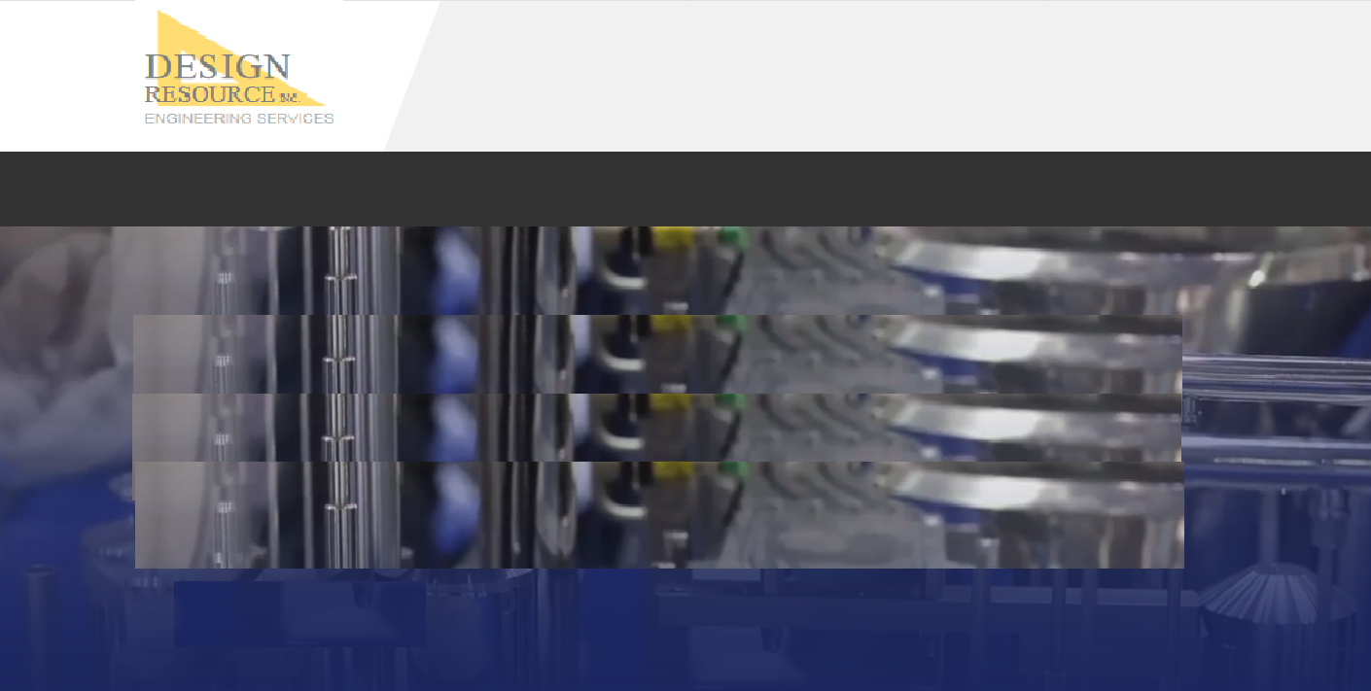

**Industrial Design**

* product rendering
* animation
* concept development

**Design for manufacture**

* SolidWorks and CREO CAD development (additional CAD platforms available)
* Design optimization
* Tolerance studies
* drawings and parts lists for manufacture

**Drawing packages**

* drawings and parts lists for manufacture

**Prototyping**

* complete build and test
* 3D printed FDM prototypes
* 3D printed SLA prototypes
* Complete inspection

Can these pics hover to a temporary full, larger image while the mouse is over them?

***A full spectrum of product development services to bring your project from concept through prototype and build.***

**HOME | ENGINEERING | STAFFING | COMPANY | CONTACT**

**© 2019 DESIGN RESOURCE, INC.**

**PRODUCT DEVELOPMENT**

**HOME ENGINEERING STAFFING COMPANY CONTACT**